**PERCEIVED ECOLOGICAL IMPACT**S **OF THE CONVERTED**

**RIPARIAN ZONE IN BARANGAY 16 QUILING SUR,**

**CITY OF BATAC, ILOCOS NORTE**

|  |
| --- |
| Undergraduate thesis manuscript submitted in partial fulfillment of the requirements for the degree of Bachelor of Science in Environmental Science from the Mariano Marcos State University, City of Batac, Ilocos Norte. College Contribution No. 11-234. Department Contribution No. 2021-27. Prepared under the guidance of Mr. Ronnel S. Pagurayan. |

**NERIZZA JEAN A. AQUINO**

**MIEL JOSHUA D. GUDOY**

**INTRODUCTION**

**Background of the Study**

Riparian areas are transitional zones between terrestrial and aquatic ecosystems. It is the interface between land and a river or stream. These areas are viewed as ecotones, or environmental gradients, between terrestrial and aquatic ecosystems (McKinstry et al., 2014). They perform vital ecological functions including their role in the protection of aquatic ecosystems by removing sediments from surface runoff, decreasing the occurrence of flooding and maintaining physio-chemical characteristic of water appropriate for aquatic life, thereby preserving their productivity and structure. They also provide excellent wildlife habitat (Machtinger et al., 2007; Anbumozhi et al., 2005).

Riparian areas also contribute to the aesthetic value of urban and agricultural regions and expand opportunities for outdoor activities. Aside from these, Chen et al. (1999) mentioned that the vegetation of these areas exerts considerable influence on the local microclimate with dense, closed canopies reducing evapotranspiration, reducing wind speed and maintaining high relative humidity. The shading from the canopy of trees in riparian vegetation, according to Kristensen et al. (2004), also keeps the temperature of the water of the stream and the air of the surrounding area low, alleviating heat stress to the occupants of the nearby residences.

However, with the rapid urbanization of the world, riparian areas have been highly modified and affected by anthropogenic activities. Some of the disturbances that are most apparent include soil pollution, trampling of vegetation and soil compaction. Worse is the increasing conversion of some areas into other land use with impervious surface, which decreases infiltration of rainfall and loss of original riparian habitat.

The degradation or removal of these areas would also mean decrease and eradication of its different ecosystem services which could result into disintegration of the dependent aquatic ecosystem and residents that lives nearby.

**Statement of the Problem**

Although there had been studies focusing on the biodiversity of riparian vegetation and its influence on the quality of its adjacent water, there were no investigations that has been found in the locality on the ecological impact of a complete eradication of a riparian vegetation. The riparian zone of the Quiaoit River was planted with forest trees and some fruit-bearing trees (e.g., Narra, Mahogany, Bamboo, Tamarind, Duhat) in 2010-2011 but was converted into a concrete road in 2018.

Generally, the study aimed to determine the perceived ecological impact of the converted riparian zone in Quiling Sur, City of Batac, Ilocos Norte.

Specifically, the study aimed to:

1. determine the ecosystem services of the converted riparian zone; and

2. determine the perception of the residents on the:

a. ecological impacts of the converted riparian zone; and its

b. socio-economic impact to the residents; and to

3. disseminate the results to the community.

**Significance of the Study**

In the locality, information on their ecosystem services were scarce which could be one of the reasons why people show no care into it. This study which aims to fill this knowledge gap will be beneficial in a way that it will provide baseline information on the importance of riparian areas.

It hopes that when the results were disseminated these could make residents, local policy makers and planners reflect on the interconnection that exist between riparian vegetation and the adjacent water body and residents. This will raise effective efforts to protect and conserve riparian habitats and biodiversity, and maintain riparian ecosystem functioning and services.

This could also provide useful information to future studies of researchers and students who will be focusing on determining the relationship of residents and riparian ecosystems.

**Scope and Limitations of the Study**

This study determined the ecological impacts of the converted riparian zone in Brgy. Quiling Sur, City of Batac, Ilocos Norte through the perception of the residents only. A survey questionnaire was used to gather the needed data**.** This was conducted on April 2021.

**REVIEW OF LITERATURE**

**Related Literatures**

**Riparian Vegetation**

Riparian vegetation grew along banks of a waterway extending to the edge of the floodplain (also known as fringing vegetation). This included the emergent aquatic plants growing at the edge of the waterway channel and the ground cover plants, shrubs and trees within the riparian zone. Riparian vegetation often showed zonation in the plant species present as the environment changes from permanently or seasonally aquatic habitats in the waterway channel and floodplain wetlands, to frequently flooded habitats along the banks and close to the channel, to drier habitats at the edge of the floodplain ([https://www.water.wa.gov.au/water-topics/waterways/values-of-our waterways/](https://www.water.wa.gov.au/water-topics/waterways/values-of-our%20waterways/)Aquatic-and-riparian-vegetation).

**Ecosystem Services**

The value of nature to people had long been recognized, but in recent years, the concept of ecosystem services had been developed to describe these various benefits. An ecosystem service is any positive benefit that wildlife or ecosystems provide to people. The benefits could be direct, indirect, small or large (https://www.n wf.org/EducationalResourcs/WildlifeGuide/UnderstandingConsevation/EcosystemServices).

**Types of Ecosystem Services in Riparian Zones**

**Provisioning services.** A provisioning service is any type of benefit to people that can be extracted from nature. When people were asked to identify a service provided by nature, most think of food, fruits, vegetables, trees, fish, and livestock. These were available to us as direct products of ecosystems. ([https://www.nwf.org/Edu cationalResourcs/WildlifeGuide/UnderstandingConsev](https://www.nwf.org/Edu%20cationalResourcs/WildlifeGuide/UnderstandingConsev)atin/EcosystemServices).

An example of provisioning services is food wherein ecosystems provided the conditions needed for growing, collecting, hunting or harvesting it. Along with food other types of provisioning services included potable water, timber, fuel wood, natural gas, oil, plants that can be made into clothes and other materials, and cultivated animal or plant species that give medicinal benefits ([http://www.fao.org/ecosystemservicesb iodiversity/background/provisioning-services/en/](http://www.fao.org/ecosystemservicesb%20iodiversity/background/provisioning-services/en/)).

**Regulating services.** A regulating service is a benefit provided by ecosystem processes that moderate natural phenomena. They provided many of the basic services that make life possible for people.

The plants cleaned air and filter water, bacteria decomposed wastes, bees pollinated flowers, and tree roots held soil in the place to prevent erosion. All these processes worked together to make ecosystems clean, sustainable functional, and resilient to change. Other regulating services included pollination, decomposition, water purification, carbon storage, climate regulation, erosion and flood control ([https:/ /www.nwf.org/Educational-Resourcs/WildlifeGuide/UnderstandingConsevati](https://www.nwf.org/Educational-Resourcs/WildlifeGuide/UnderstandingConsevati)on/Eco systemServices).

**Cultural services.** Cultural services are those “non-material benefits people obtain from ecosystems through spiritual enrichment, cognitive development, reflection, recreation, and aesthetic experiences” (Millennium Ecosystem Assessment, 2005).

The importance of ecosystems to the human mind could be traced back to the beginning of mankind of ancient civilization drawing pictures of animals, and weather patterns on cave walls. It contributed to the development and cultural advancement of people, including how ecosystem play a role in local, national, and global cultures; the building knowledge and the spreading of ideas; creativity born from interactions with nature, music, art, architecture and recreation ([https://www.nwf.org/EducationalResou rcs/WildlifeGuide/UnderstandingConsev](https://www.nwf.org/EducationalResou%20rcs/WildlifeGuide/UnderstandingConsev)atin/EcosystemServices).

**Supporting services.** Supporting services are services that have little or no direct benefit to people and involve all biophysical structure and processes. These ecosystem services supported and maintained ecosystems in a favorable condition and enabled the provision of ES by the ecosystem such as a river with good water quality that can support fishes (Riis et al. 2020).

Other examples included natural processes such as photosynthesis, nutrient cycling, the creation of soils, and the water cycle. These processes allowed the Earth to sustain basic life forms, let alone whole ecosystems and people. Without supporting services, provisional, regulating, and cultural services wouldn’t exist (https://www.nw f.org/Educational-Resourcs/WildlifeGuide/UnderstandingConsevatin/EcosystemServ ices).

Specific example of supporting services in the riparian zone included its contribution in pollination and seed dispersal. Riparian vegetation provided important nesting and foraging sites (nectar and pollen) for pollinators which contributed to higher pollination success to habitats within the proximity of the area (Garibaldi, et al., 2014; Petersen and Nault, 2014). The favorable conditions within the riparian vegetation made it also possible for seed germination and seed establishment especially to terrestrial species that rely on hydrochory (Merritt and Wohl, 2006).

**Human Influences That Affect Riparian Zones**

It was not new that whenever humans interact with the environment, they somehow influenced how it works. As the third environmental principle states, everything is connected to everything else, and riparian zones are no exceptions. Following are some activities of humans that significantly alter the said zones.

**Road building.** With the onset of modernization, road building had been one of the activities of man. This activity caused accelerated erosion, introduced oil and other pollutants to the stream, cut off subsurface water flow to the stream and threatened the riparian wildlife. This activity also lead to complete eradication of the existing vegetation (<https://extension.usu.edu/waterquality/wshedinformati/humaninfl> uences).

**Farming.** Another activity that had significant impact is farming. Usually due to the demand of lands to be cultivated, vegetation of stream banks of the riparian zones was eradicated inducing the occurrence of soil erosion. With the observance of the farmers to this phenomenon, wherein after a couple of seasons, eventually their farmland was lost when erosion occurs and sedimentation increases downstream, more farmers adapted into it and realized that maintaining the health of their riparian areas ensure long-term sustainability of their land (<https://extension.usu.edu/waterquality/w> shedinformati/humaninfluences).

**Grazing.** Although, riparian zones were good source of food for animals like cows, goat and other land farm animals, the overgrazing in the riparian zone caused changes in the types of vegetation and the amount of cover and forage. It also increased erosion, and introduced increased amounts of nutrients and fecal coliform bacteria to the stream through manure (<https://extension.usu.edu/waterquality/wshedinformati/hu> maninfluences).

**Development.** Aside from the roads, housing or commercial development was also one of the anthropogenic activities in a riparian zone. This often caused the removal of vegetation and altered the stream banks. These changes could increase the intensity of floods, increased the direct input of pollutants to water, and decreased wildlife. If this happens, upland and the vegetation was stripped away, too much water was allowed to flow down into the stream at one time, which could lead to bank erosion, deep, and narrow channels, shrunken riparian zones, and often increased loads of sediments (https://exte nsion.usu.edu/waterquality/wshedinformati/humaninfluence s).

**Natural Influences That Affect Riparian Zones**

**Water supply.** Water supply is the major factor that regulates growth of riparian vegetation. Flood waters transported nutrients, sediment and new seeds from upstream. Floods also stripped away larger, established vegetation and allowed new seedlings to establish ([https://extension.usu.edu/waterquality/watershedinformation/h umaninflu](https://extension.usu.edu/waterquality/watershedinformation/h%20umaninflu)ences).

**Soil type.** In the riparian zone, soil type influenced the amount of water and nutrients available. Organic rich soil held the water and provided abundant nutrients to plays, without releasing this nutrient in the water. We could expect to find denser vegetation in these soils than in gravely soil with little water-holding capacity and few nutrients ([https://extension.usu.edu/waterquality/watershedinfo/humaninflu](https://extension.usu.edu/waterquality/watershedinformation/humaninflu)ences).

**Topography.** Topography or shape of the land, affected the location and abundance of plants in the riparian zone ([https://extension.usu.edu/waterquality/waters hedinformation/humaninflu](https://extension.usu.edu/waterquality/waters%20hedinformation/humaninflu)ences).

**Climate.** Climate affects the appearances of the riparian zones. In the deserts riparian zones were “green oases” in sparse, dry surroundings. Where precipitation was more abundant, like in the mountains, the upland vegetation remained relatively lush (<https://extension.usu.edu/waterquality/watershedinformation/humaninflu>ences).

**Impact of Destroyed Riparian Zone**

**Flood.** Riparian vegetation reflected the impact of a flood via two processes: (1) the destruction of pre-existing vegetation by the flood, and (2) the colonization by new vegetation of substrate either cleared or deposited by the flood (Bendix, 1998). The riparian vegetation served as a buffer to the impacts of flood and with the eradication of it, the nearby communities was expected to be massively affected.

**Loss of habitat to animals.** Riparian zones were ideal habitat for various living organisms including animals. With the increasing disappearance of these areas due to different anthropogenic activities, like agriculture, housing, roads, pipelines and other hallmarks of industrial development, the loss of habitats for these organisms was expected (<https://www/f.panda.org/discover/our_focus/wildlife_practice/problems/ha> bitat_loss_degradation/).

**Lesser production of fresh air.**  Plants such as trees and shrubs played a huge role in the carbon cycle, they converted the carbon dioxide in the air to oxygen, through the process of photosynthesis, and in this way, and they could be locked at as a natural regulator of the carbon dioxide. The more trees, the less carbon dioxide in the atmosphere and the more oxygen (Jakuboski, 2012). With the eradication of trees, shrubs and other species of plants in the zone, one impact that is expected was the decrease of the production of oxygen in the area.

**Hotter temperature.** Deforestation, the depletion of forests and other wild flora in woodlands, had significant effects on the weather. These range from local distortions to contributions to global climate change. Deforestation in a riparian zone, thus, removed the ability of the forest to sequester carbon, absorbed sunlight, processed water and blocked the wind (Gellert, 2017) causing hotter temperature.

**Related Studies**

A study conducted by Riis et al. (2020) recommended a framework in order to guide management of the vegetation in riparian zones. It emphasized the need to gather information on the provisioning, regulating, maintaining (supporting) and cultural services of the riparian areas for policy makers to have a basis in constructing comprehensive management plan.

Another study conducted by Luke et al. (2018) which focused into the current riparian policies and the scientific-based available information in tropical countries suggested closer collaboration and improved data sharing between scientists, policy-makers, environmental managers and local practitioners to build local capacity.

In the Philippines, where an assessment of the floral resources and livelihood development in Malindang Range, Misamis Occidental by Amoroso and Arances (2002) found that the riparian zone have 39 species that are medicinal, 14 species used as food, 18 species classified as ornamental and 90 species used as lumber, firewood or as raw materials for handicraft making.

In the locality, Agustin and Tabuyo (2018) found that the presence of trees in Quiaoit River is very ecologically important because of their microclimate regulation function as carbon dioxide sink which maintained good air quality and reduced air pollution. These services reduced air pollution-related health problems to the people living in the area.

**Conceptual Framework of the Study**

Riparian zones provided different ecosystem services which support human welfare and development. However, with the rapid urbanization of towns and cities brought upon by modern technological advancements, riparian zones had been converted into different land uses like roads and flood protection walls. And along with the eradication of these areas was the loss of ecosystem services human communities depend upon for their living.

This is also the case for the riparian zone in Barangay Quiling Sur, City of Batac, Ilocos Norte wherein the previous vegetation of the area was eradicated in order to make way to the construction of a road.

Such looming event happened due to the lack of deep understanding of policy makers, land-use planners, and the people in general to the different ecosystem services these areas provide.

Change in Riparian Land-Use and Cover

* Human well-being
* Basic materials for a good life
* Health
* Good social relations

ECOSYSTEM SERVICES

* Provisioning
* Supporting
* Cultural
* Regulating

Fig 1. Conceptual framework of the study. ­­

**Definition of Terms**

**Ecosystem Services (ES).** These were the benefits provided by the riparian zone to the residents of Quiling Sur, City of Batac, Ilocos Norte. These could be categorized into four; provisioning, regulating, supporting and cultural.

**Households.** Referred to all the household along the eradicated riparian vegetation in Quiling Sur, City of Batac, Ilocos Norte.

**Perceived Ecological Impact.** This referred to the ecological impact caused by the eradication of the riparian vegetation along Quiaoit River.

**Riparian Zone.** In this riparian zone referred to the vegetation along the Quiaoit River.

**METHODOLOGY**

**Locale of the Study**

The study was conducted at Barangay Quiling Sur, City of Batac, Ilocos Norte where a part of the riparian area was converted to a cemented road. City of Batac is located in the northwest of Luzon Island, 470 kilometers from Metro Manila and 17 kilometers from Laoag, the provincial capital of Ilocos Norte. (https://www.philatla s.com/luzon/r01/ilocos-norte/batac.html).

Quiling Sur is a few meters away from the Mariano Marcos State University -one of the institutions that provide employment to the local community. According to 2015 Census, the barangay had a total population of 2, 838 (<https://www.Philatlas.co> m/luzon/r01/ilocos-norte/batac/quiling-sur.html).

The study area were the households near the eradicated portion of the riparian zone starting from the barangay tanod outpost along the Quiling Sur Main Road until the bridge in front of the Quiling Sur Elementary School. Nearby households from both banks of the river was included in the study. The study area was 500 meters long (Figure 1).

**Research Design and Variables of the Study**

The study used a descriptive type of research. Descriptive method was used to gather information on the impact of converted riparian area. There were two variables of the study; the ecosystem services of the riparian zone to the residents and the perceived ecological impact of its conversion to the residents in affected area.

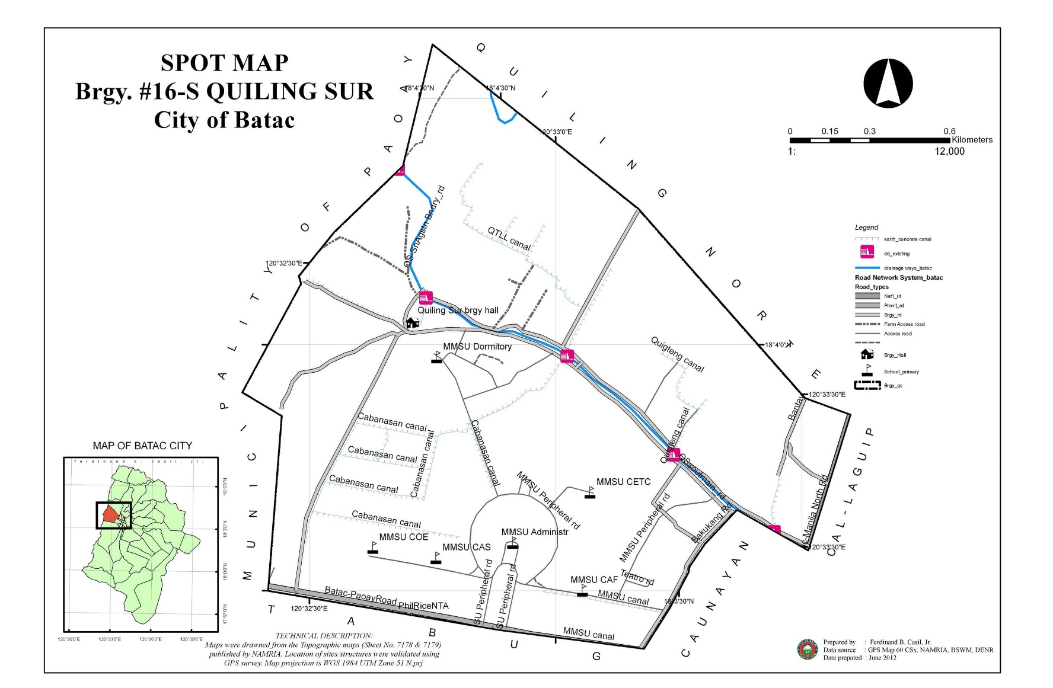­­­­­­­­

­­

­­­­­­

Study Area

16

Fig. 1. Map of the study area (Casil, F., 2012).

**Unit of Analysis**

17

The residents in the affected area in Barangay Quiling Sur were the unit of

analysis of the study.

**Population and Sample**

The study used purposive sampling method. With this method, only the households within the vicinity of the converted riparian zone were included in the study. This included 60 households which are within the converted riparian zone. The determination of the number of households was done through coordination with the barangay secretary.

**Research Instrument**

In gathering the data, a structured-type guide questionnaire was utilized. It designed into three sections and was covered the socio-demographic information of the respondents, the ecosystem services of the converted riparian zone and the socio-ecological impact of the conversion into a different land-use.

**Data Gathering Procedure**

Before the conduct of the research, the researcher requested permission to gather data and information through a letter to the office of Mayor of City of Batac, Ilocos Norte. Personal interviews were conducted to maximize response rates. The questionnaire was constructed in English but translated in Iloko prior to data collection to obtain reliable responses. It was done in the month of April 2021.

**Data Analysis**

Data gathered was subjected to statistical analysis specifically descriptive statistics such as frequency distribution, and percentages which used to describe the ecosystem services and ecological impact of the eradicated riparian as perceived by the residents, and the socio-demographic profile of the residents in affected area.

**RESULTS AND DISCUSSION**

**Socio-Demographic Profile of the Respondents**

The study focused on the different services especially the ecosystem services of the eradicated riparian zone. There are four major services of such ecosystem. These are provisioning services, regulating services, cultural services, and supporting services.

Table 1 showed the socio-demographic profile of the residents along the riparian zone in Quiling Sur, City of Batac including gender, age, household size, and highest educational attainment.

**Gender and Age.** Based on the demographic profile of respondents, it can be seen in Figure 1 that most of the respondents were male 58% while 42% are female. Most of them are 60 years of age and above and between 31 to 40 years of age with a slight percentage difference of more than 3% which is 33% and 30%, respectively.

**Household Size.** The greatest number of household members consisted of 4 – 6 members in which they were accounted for 48% of the whole sampling population which means that there was a tight family relation in terms of family affairs and other related matters such as Filipino values of being together including extended families.

**Highest Educational Attainment.** Most of the respondents were high school graduates and college graduates in which it is comprised of 30% and 28%, respectively wherein, they understood the researchers’ aims and goals in this study.

Table 1. Socio- demographic profile of the respondents in Quiling Sur, City of

Batac, Ilocos Norte (n=60).

|  |  |  |  |  |
| --- | --- | --- | --- | --- |
| PROFILE | FREQUENCY (f) | | PERCENTAGE | |
| **Gender** | |  | |  |
| Male | | 35 | | 58 |
| Female | | 25 | | 42 |
| **Age** | |  | |  |
| 30 and below | | 2 | | 3 |
| 31-40 | | 18 | | 30 |
| 41-50 | | 8 | | 13 |
| 51-60 | | 12 | | 20 |
| 61 and above | | 20 | | 33 |
| **Household Size** | |  | |  |
| 1 – 3 | | 22 | | 37 |
| 4 – 6 | | 29 | | 48 |
| 7 and above | | 9 | | 15 |
| **Educational Attainment** | | | |  |
| Elementary Level | | 2 | | 3 |
| Elementary Graduate | | 6 | | 10 |
| High School Level | | 5 | | 8 |
| High School Graduate | | 18 | | 30 |
| Vocational Graduate | | 2 | | 3 |
| College Level | | 10 | | 17 |
| College Graduate | | 17 | | 28 |

**Ecosystem Services of the Eradicated Riparian Zone**

Based from the results shown in Table 2, it can be implied that there are four main provisioning services the riparian vegetation provides to the community including the source of traditional medicines (95%), the provision of fuel wood (78%) and food (60%), and the provision of raw materials for their homes (77%). The provision of traditional medicines like horse radish (locally known as *malunggay*), banana, and among others is very helpful in their daily lives. These six provisioning services reiterated that the ecosystem is very important in their daily lives.

On the other hand, the least two services wherein the ecosystem provides water (5%); and a source of timber (3%).

Table 2. Provisioning services of the eradicated riparian zone (n=60).

|  |  |  |  |
| --- | --- | --- | --- |
| **PROVISIONING SERVICES**\* | FREQUENCY (f) | PERCENTAGE | RANK |
| Source of traditional medicine | 57 | 95 | 1 |
| Source of fuel wood | 47 | 78 | 2 |
| Provides raw materials | 46 | 77 | 3 |
| Provides food | 36 | 60 | 4 |
| Provides water | 3 | 5 | 5 |
| Source of timber | 2 | 3 | 6 |

*Multiple responses

The perception of the respondents based on Table 3 is shown below wherein regulating services of the Eradicated Riparian Zone.

The three main regulating services of the area include protection against strong winds, protection against floods, and purifies air. First, it was a protection against strong winds in which trees protecting the area and the nearby surrounding places with a percentage of 92%. It is shown that people were looking for their houses for the safety of their family members. Second, it was a protection against floods with an average percentage of 88%, wherein trees and shrubs were important in protecting the community in the said calamity. Third, plants and trees were very helpful in terms of purifying the air with 68%.

The other two were protection against landslide (67%) and purifies water (37%). These two were also important to the respondents wherein trees and plants held soil against landslides and purifies water for household usage.

Table 3. Regulating services of the eradicated riparian zone (n=60).

|  |  |  |  |
| --- | --- | --- | --- |
| **REGULATING SERVICES**\* | FREQUENCY (f) | PERCENTAGE | RANK |
| Protection against strong winds | 55 92 | | 1 |
| Protection against flood | 53 88 | | 2 |
| Purifies Air | 41 68 | | 3 |
| Protection against landslide | 40 67 | | 4 |
| Purifies water | 22 37 | | 5 |

*Multiple responses

On Table 4, results shown that perceived cultural impacts of the riparian zone. First, the area serves as their recreational place (82%); second, it provided a sense of home or a part of their being at such (50%); and third, it served as inspiration for work of art (17%).

These observations were strongly agreed on such level of importance in their daily life in terms of mental health, physical matters, and being part of belongingness in such harmonious community, between nature and mankind.

Table 4. Cultural services of the eradicated riparian zone (n=60).

|  |  |  |  |
| --- | --- | --- | --- |
| **CULTURAL SERVICES**\* | FREQUENCY (f) | PERCENTAGE | RANK |
| Recreational place | 49 82 | | 1 |
| Sense of home | 30 50 | | 2 |
| Inspiration for work of art | 10 17 | | 3 |
| Serves as cultural identity | 3 5 | | 4 |

*Multiple responses

There were two noted supporting services revealed and these are shown in Table 5. First, 80% of the sampling population agreed that the ecosystem provides them habitat for pollinators and organisms responsible for recycling of nutrients based on the environmental background. It is noted that such as dragon flies, bees, and other insects were beneficial to environment as well as to humans’ needed resources.

Secondly, the respondents agreed also that they provided for the establishment and germination of seeds transported by the water (55%) of the river to the river banks and created a great harmonious co-existence of the living things surrounding the area.

The last two provisions of this service are the provision of shelter or habitat for farm animals such as pigs, cows, carabaos, and among others with 32%, and provision nutrients through the food growing in that area, same with 32%.

Table 5. Supporting services of the eradicated riparian zone (n=60).

|  |  |  |  |
| --- | --- | --- | --- |
| **SUPPORTING SERVICES**\* | FREQUENCY (f) | PERCENTAGE | RANK |
| Provides habitat for pollinators  and organism responsible for  the recycling of nutrients | 48 80 | | 1 |
| Provides area for the  establishment and  germination of seeds  transported by water or the  river | 33 55 | | 2 |
| Shelter/habitat for farm  animals | 19 32 | | 3 |
| Provides nutrients through the  food growing in it | 19 32 | | 3 |

*Multiple responses

**Ecological Impacts of the Converted Riparian Zone**

**Impacts on Air.** There are two identified impacts of the riparian eradication that were observed by all of the respondents (100%). It shortened the days with fresh air and the temperature of the ambiance in such locations becomes hotter than the past years; created strong winds when typhoon comes which is 55%; and lastly, worsen air pollution has a percentage of 37%. As such perceptions of the population, it was very much noted that trees and plants surrounding the area has something to do with the quality of the air and the temperature rises. Thus, it should not be wasted as such good ecosystem around the riparian zone. This is shown in Table 6 below.

Table 6. Impacts of the converted riparian zone in terms of air quality (n=60)

|  |  |  |
| --- | --- | --- |
| **IMPACT ON AIR**\* | FREQUENCY (f) | PERCENTAGE |
| Less days with fresh air | 60 100 | |
| Create high temperature in the  area | 60 100 | |
| Worsen pollution in the area | 22 37 | |
| Create strong winds when  typhoon comes | 33 55 | |

*Multiple responses

**Impacts on Water.** Table 7 shows the perceived impact on water of the eradication of the riparian zone. First, fishes caught in the river has lessened in terms of numbers (82%).

Secondly, there was loss of fish species and other fresh water creatures in the area (78%) like *dukyang* and *tutut*. Thirdly, there was more frequent flooding when in times of typhoons and rainy season (53%). Lastly, water became dirty with 15%.

In the table 7 below, there was a big impact of the converted riparian zone in terms of water because it could affect the respondents for their daily lives especially that fishes and other fresh water creatures were important as a part of their diet or daily food. It is also noted flooding could cause damage to their homes as well as their sources of food and water.

Table 7. Impacts of the converted riparian zone in terms of water quality n=60).

|  |  |  |
| --- | --- | --- |
| **IMPACT ON WATER\*** | FREQUENCY (f) | PERCENTAGE |
| Frequent Flooding | 32 53 | |
| Loss of fish species | 47 78 | |
| Lessened of fishes caught | 49 82 | |
| Water becomes dirty | 9 15 | |

*Multiple responses

**Impacts on Land.** There were three important observations on the impacts of the riparian eradication on the land.

First, the removal of the area where bananas, bamboo trees, and other crops/root crops were originally planted (87%). Second, it lessened or loss of area of gathering or source of fuel wood (83%) as such, it was very important to the community since that they had different economic background of each individuals and families along the river. Third was the removal of the area for planting vegetables and other crops to be planted along the riverbanks with 78%.

Fourth was the removal of place for domesticated pigs, cows and carabaos with a percentage of 20%.

The last but not the least was the removed place for cows and carabaos as grazing land (12%). Few of the respondents are not grazing in the area. Base on the interview of the researchers, the respondents said that they are following the rules in the said barangay. Still, it has a small impact to the respondents for their domesticating animals like cows and carabaos.

Table 8. Impacts of the converted riparian zone in terms of land quality (n=60).

|  |  |  |
| --- | --- | --- |
| **IMPACT ON LAND** | FREQUENCY (f) | PERCENTAGE |
| Removed land for plants for food source | 52 87 | |
| Removed source of fuel wood | 50 83 | |
| Removing place of domesticated pigs,  cows and carabaos | 12 20 | |
| Removing place for cows and carabaos  grazing land | 7 12 | |
| Removing place for planting vegetables | 47 78 | |

*Multiple responses

**Socio-economic Impacts of the Converted Riparian Zone**

There were three most notable observations on the socio-economic impacts of the sampling population and these are shown in Table 9.

First is the loss of recreational place or mental enhancement or related to well-being with a percentage of 98%. Secondly, loss of area to be gathered of sustaining food rations or food allotment on their tables such as bananas, bamboo shoots, and other crops/vegetables/root crops such locally planted crops like aba, kamotig, and other important Ilocano food diet with 80%. Thirdly, this service was also source of ground water, the level of such had been lowered, such as it was hard to get tap water or sometimes, no such water to be get due to eradication of plant species and tree species along the riverbanks that could held water wherein riparian zone has been established or created with 53%. However, there are only few of them noted that the less number of domesticating animals like pig, cow and carabao in the area with 15% in which it had positive ecological impact because of the animal waste that flow through the water wherein it could degrade the water quality. However, these negative economic impacts where animals exposed too much of sunlight could endanger animals’ well-being. Lastly, they were higher cases of heat stroke in the area or higher chances to heat stroke with 5% in which it also had big impact to the community.

Table 9. Impacts of the converted riparian zone in terms of people (n=60).

|  |  |  |
| --- | --- | --- |
| **IMPACT ON PEOPLE** | FREQUENCY (f) | PERCENTAGE |
| Loss of recreational place | 59 98 | |
| Loss of plants and trees for food  source | 48 80 | |
| Less number of domesticating  animals like pig, carabao and  cow | 9 15 | |
| Higher case of heat stroke in the  area | 3 5 | |
| Shallowing deep wells | 32 53 | |

*Multiple responses

**Dissemination of Results of the Study to the Community**

The researchers made use of pamphlets to disseminate the results of the study to the community. Households along the river were given these pamphlets containing the information of the impact riparian eradication, with the hope of instilling in their minds the importance of conserving and protecting these areas.

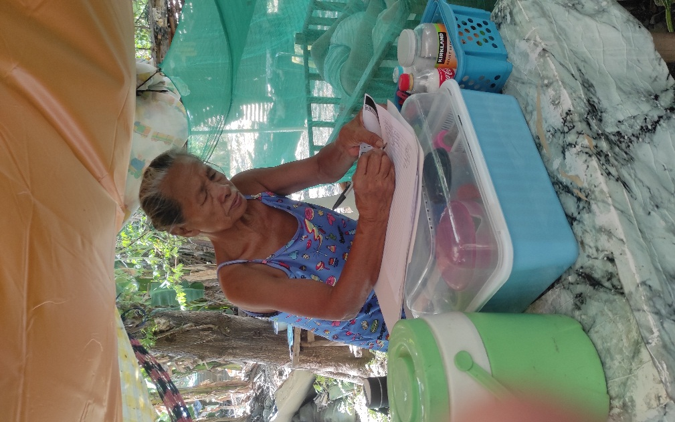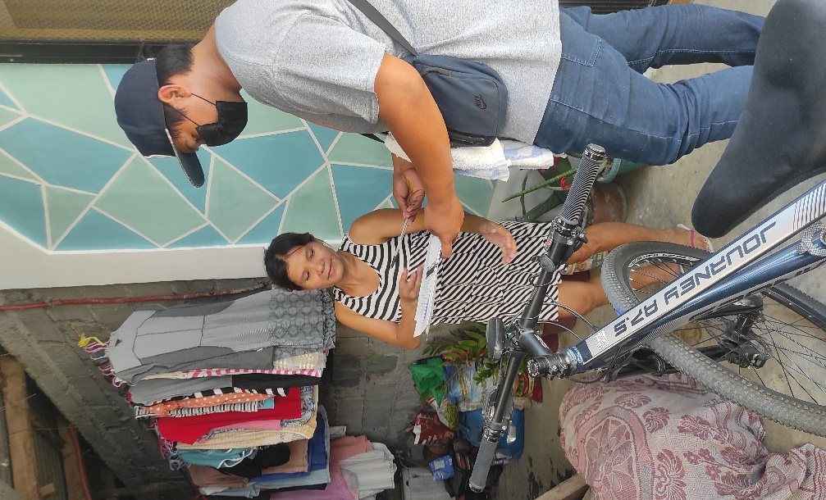Aside from them, the results were also disseminated to the barangay officials for future policy implications especially that the City Government still have plans of continuing channelization of the river.

Fig. 3. Disseminating the results to the community

**SUMMARY, CONCLUSION, AND RECOMMENDATION**

**Summary of Findings**

This study aimed to determine the perceived socio-ecological impact of the converted riparian zone along Quiaoit River in Quiling Sur, City of Batac, Ilocos Norte. Specifically, it aimed to (1) determine the ecosystem services of the converted riparian zone; (2) identify the perception of the residents on its ecological and socio-economic impacts; and (3) to disseminate the results of the study to the community.

The study used descriptive research design in gathering data such as socio-demographic information of the respondents, the ecosystem services of the converted riparian zone, and the socio-ecological impacts of the conversion into a different land-use. Frequency distribution and percentages were used in the data analysis.

Majority of the respondents were males which consisted of 58% and most of them were above 60 years of age. Majority of the respondents had 4-6 members with a background of high school and college education.

The identified ecosystem services were categorized into four; provisioning, regulating, cultural and supporting services. The provisioning services of the riparian zone to the residents include the provision of raw materials, food, traditional medicines, and fuel wood. As to its regulating services, the residents believed that it protected them against destructive wind and floods while it have also purified the air and water in the area.

On the other hand, the cultural services that it has offered include its purpose as a recreational place for the residents and the feeling or sense of home that it made the residents feel. As for its supporting services, it has provided habitat for pollinators and organism responsible for the recycling of nutrients and have been an area that has allowed the establishment and germination of seeds transported by the river’s water.

In terms of the impacts of the conversion of the riparian zone to the community, the respondents noted that it has negatively affected the quality of air in their area, it reduced the number of their freshwater fish catch and has drastically caused floods for the past years.

Apart from these, it had also removed the area previously planted by the residents with crops such as bananas, trees and other root crops and as well as eradicated the place where they used to collect their fuel wood. All of these have affected negatively their socio-economic condition. The results were disseminated to the residents and the barangay officials through a pamphlet.

**Conclusions**

Based on the result in the riparian zone of the Quiaoit River in Quiling Sur, City of Batac, Ilocos Norte have served provisioning, regulating, cultural and supporting services in the area. Its eradication have caused negative changes to these ecosystem services which influenced in turn changes in some of the socio-economic activities of the community.

**Recommendations**

Based on the summary of the results and the conclusions drawn, the following are the recommendations of the study:

1. The barangay should create ordinances in conserving the riparian zone to maintain the ecosystem services that it provides.
2. The ecosystem services of the riparian zone should be considered by local land-use planners in developing construction projects in the area.
3. Environmental valuation studies should be conducted on riparian areas in order to further strengthen the basis in the conduct of its conservation and protection.

**LITERATURE CITED**

**AMOROSO, V.** and **J. ARANCES.** 2002. Participatory Inventory and Assessment of Floral Resources and Livelihood Development in Malindang Range, Misamis Occidental. Unpublished.

**AGUSTIN, K.Q.** and **TABUYO, C.D.** 2018. Carbon Dioxide Sequestration Estimate of Established Trees along the Riparian Zone of Quiaoit River, Quiling Sur, City of Batac, Ilocos Norte. Unpublished Undergraduate Thesis. Mariano Marcos State University, City of Batac, Ilocos Norte 39 pp.

**ANBUMOZHI, V., J. RADHAKRISHNAN,** and **E. YAMAJI.** 2005. Impact of Riparian Buffer Zones on Water Quality and Associated Management Considerations. *Ecological Engineering,* 24, pp. 517-523.

**BENDIX J.** 1998**.** Impact of a flood on Southern California Riparian Vegetation. Retrieved on December 9, 2020 from <https://www.maxwell.syr.edu/upload> edFiles/faculty/geo/Bendix_98_PhysGeog_FloodImpact.pdf.

**BREN, L.J.** 1993. Riparian Zone, Stream, and Floodplain Issues. Retrieved on March 8, 2021 from <https://www.scriencedirect.com/scrience/article/abs/pii/00221> 6949390113N.

**CHEN, J., S. SAUNDERS, T. CROW, R.J. NAIMAN, K. BROSOFSKE, G. MROZ, B. BROOKSHIRE,** and **J.F. FRANKLIN.** 1999. Microclimate in forest ecosystem and landscape ecology. BioScience 49:288–297.

**DEBANO, L.F.** and **HEEDE, B.H.** 1987. Enhancement of riparian Ecosystem with Channel Structures. Retrieved on March 8, 2021 from https://onlinelibrary.wile y.com/doi/abs/10.1111/j.1752-1688.1987.tb00824.

**GARIBALDI, L.A., L.G. CARVALHEIRO, S.D. LEONHARDT, M.A. AIZEN, B.R. BLAAUW, R. ISAACS, M. KUHLMANN, D. KLEIJN, A.M. KLEIN, C. KREMEN, L. MORANDIN, J. SCHEPER, R. WINFREE.** 2014. from research to action: Enhancing crop yield through wild pollinators. Frontiers in Ecology and the Environment 12: 439–447.

**GELLERT, A.** 2017. How Does Deforestation Affect the Weather? Retrieved from https://sciencing.com/deforestation-affect-weather-23869.html on December 11, 2020.

**JAKUBOSKI, S.** 2012**.** Deforestation and Global Warming. Retrieved from [https:/ /www.nature.com/scitable/blog/greenscience/deforestation_and_global_warming](https://www.nature.com/scitable/blog/greenscience/deforestation_and_global_warming) on December 11, 2020.

**KRISTENSEN, P.B., E.A. KRISTENSEN, T. RIIS, A.J. BAISNER, S.E. LARSEN, P. VERDONSCHOT, BAATTRUP,** and **A. PEDERSEN.** 2014. The effect of forest on stream temperature. Inland Waters 5: 27–38.

**LUKE, S.H., E.M. SLADE, C.L. GRAY, K.V. ANNAMMALA, J. DREWER, J. WILLIAMSON, A.L. AGAMA, M. ATIONG, S.L. MITCHELL, C.S. VAIRAPPAN** and **M.J. STRUEBIG.** Riparian buffers in tropical agriculture: Scientific support effectiveness and directions for policy. Journal of Applied Ecology 56: 85–92.

**MACHTINGER, E.T., R. MARKS, W. HOHMAN, S. CRAVE, G. BARICKMAN, R. NELSON,** and **T. BAKER.** 2017. Riparian Systems. Retrieved from https://www.resear chgate.net/publication/265822856_Riparia n_Systems on December 10, 2020.

**MILLENIUM ECOSYSTEM ASSESSMENT.** 2005 A Report of the Millennium Ecosystem Assessment. Ecosystems and Human Well-Being. Island Press, Washington DC.

**MERRITT, D.M. and E.E. WOHL**. 2006. Plant Dispersal Along Rivers Fragmented by Dams. Wiley Inter Science. Retrieved from [https://10.1002/rra.890 on February 14](https://10.1002/rra.890%20on%20February%2014), 2021.

**PETERSEN J.D., B.A. NAULT.** 2014. Landscape diversity moderates the effects of bee visitation frequency to flowers on crop production. Journal of Applied Ecology 51: 1347–1356

**RIIS, T., M. KELLY-QUINN, F.C. AGUIAR, P. MANOLAKI, B. BRUNO, M.D. BEJARANO, N. CLERICI, M.R. FERNANDEZ, J.C. FRANCO, N. PETTIT, A.P. PORTELA, O. TAMMEORG, P. TAMMEORG, P.M. RODRIGUEZ-GONZALES,** and **A.S. DUFOUR.** 2020**.** Global Overview of Ecosystem Services Provided by Riparian Vegetation. Retrieved from <https://www.researchgate.net/publication/341219394_Global_Overview_of_Ecosystem_Services_Provided_by_RIparian_Vegetation> on December 10, 2020.

**STEVENS, A.** 2010. Dynamics of Predation. Nature Education Knowledge 3(10):46 Retrieved from https://www.nature.com/scitable/knowledge/library/dynamics -of-predation-13229468 on December 19, 2020.

https://wwf.panda.org/discover/our_focus/wildlife_practice/problems/habitat_loss_degradation/. Retrieved on December 11, 2020.

https://www.water.wa.gov.au/water-topics/waterways/values-of-our-waterways/aqua tic-and-riparian-vegetation. Retrieved on December 19, 2020.

<https://www.nap.edu/read/10327/chapter/5#147>. Retrieved on December 19, 2020.

[https://www.iwapublishing.com/news/flood-control-and-disastermanagement. Re](https://www.iwapublishing.com/news/flood-control-and-disastermanagement.%20Re)trieved on December 19, 2020.

[https://www.nwf.org/Educational-Resources/Wildlife-Guide/Understanding-Conserv ation/Ecosystem-Services](https://www.nwf.org/Educational-Resources/Wildlife-Guide/Understanding-Conserv%20ation/Ecosystem-Services). Retrieved on December 19, 2020.

[https://extension.usu.edu/waterquality/watershedinformation/humaninfluences. Retrie](https://extension.usu.edu/waterquality/watershedinformation/humaninfluences.%09Retrie)ved on December 20, 2020.

<http://www.fao.org/ecosystem-services-biodiversity/background/provisioning-service> s/en/. Retrieved on January 9. 2021.

[http://lib.freshwatertools.eu/index.php/infolib/ecoservices/cultural-ess.html. Retrieved](http://lib.freshwatertools.eu/index.php/infolib/ecoservices/cultural-ess.html.%09Retrieved) on January 9. 2021.

<https://www.sciencedirect.com/topics/agricultural-and-biological-sciences/seed-dispe> rsal. Retrieved on March 8, 2021.

[https://www.nap.edu/read/10327/chapter/3#](https://www.nap.edu/read/10327/chapter/3). Retrieved on March 8, 2021.

**APPENDICES**

**Appendix A: Letter (Letter to the Municipal Mayor)**

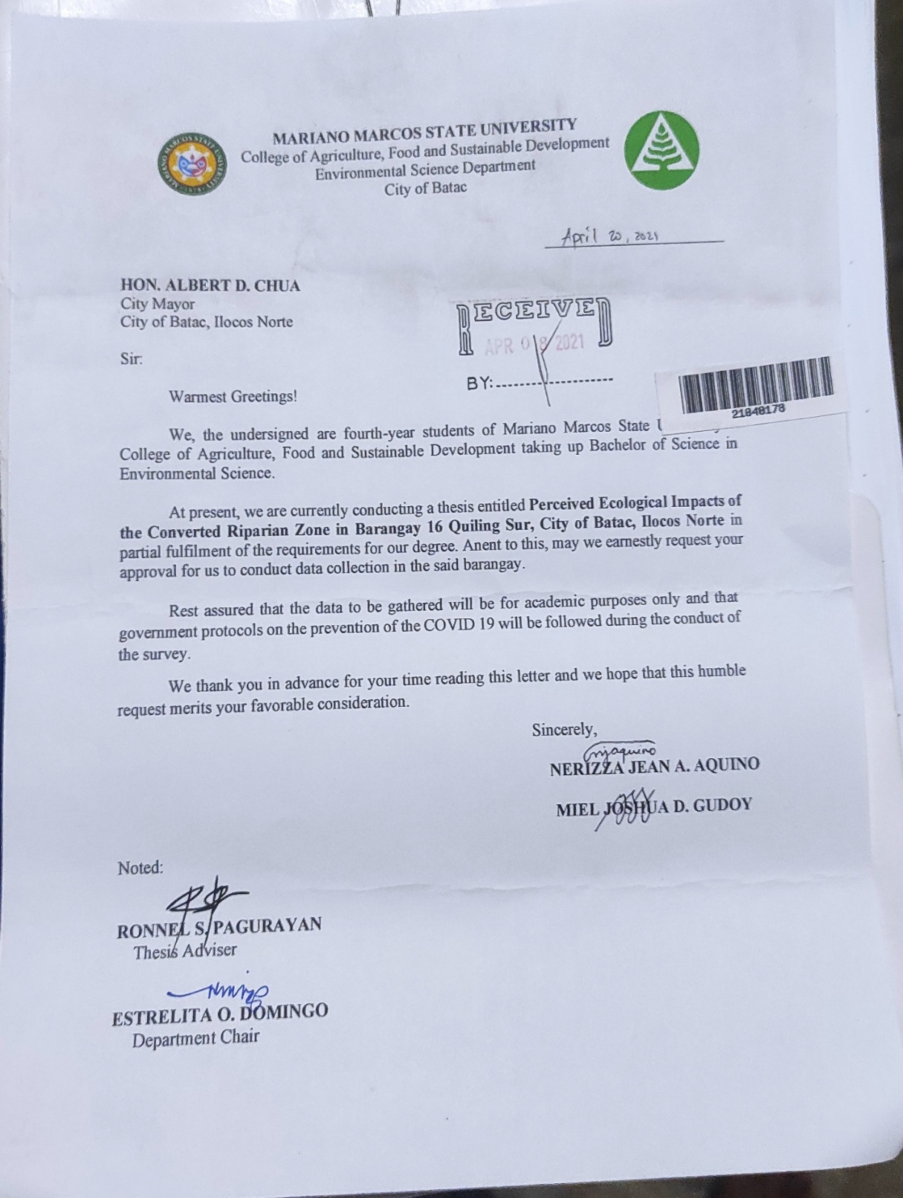

**Appendix B: Survey Questionnaire**

**I. DEMOGRAPHIC PROFILE OF THE RESPONDENT**

A. Respondent’s Personal Information

1. Name *(Nagan):* ________________________________

2. Age *(Tawen)*: ___

3. Household Size *(Bilang iti myembro ti pamilya)*: ____

4. Sex *(kinatao)*: [ ] Male *(Lalaki)* [ ] Female *(Babai)*

5. Marital Status:

[ ] Single *(Awan asawa)* [ ] Married *(Addaan Asawa)*

[ ] Widow *(Balo)* [ ] Separated *(Nagsina)*

1. Highest Educational attainment *(Kangatoan a nagun-od nga edukasyon)*

[ ] No Formal Education

[ ] Elementary Level

[ ] Elementary Graduate

[ ] High School Level

[ ] High School Graduate

[ ] Vocational Graduate

[ ] College Level

[ ] College Graduate

**II. ECOSYSTEM SERVICES OF THE ERADICATED RIPARIAN ZONE**

**Direction:** Please identify the ecosystem services that were provided by the riparian zone before it was converted. (*Anya dagiti maipapaay idi iti riparian zone sakbay nga pinagbalin nga kalsada?*

|  |  |
| --- | --- |
| **A.** **PROVISIONING SERVICES** | |
| Provides Food. (*Mangipapaay ti taraon)* |  |
| Provides Water. (*Mangipapaay ti danum)* |  |
| Provides Raw materials. (*Paggapwan ti materyales kasla kuma kawayan)* |  |
| Source of Fuel Wood. (*Paggapuan ti pagsungrod)* |  |
| Source of Lumber. (*Paggapuan ti tabla)* |  |
| Others, please specify: | |

|  |  |
| --- | --- |
| **B**. **REGULATING SERVICES** | |
| Source of traditional medicines. (*Paggapuan tradisyunal a agas)* |  |
| Protection against strong winds. (*Proteksiyon ti napigsa a angin)* |  |
| Protection against flood. (*Proteksiyon ti layus)* |  |
| Protection against landslides. (*Proteksiyon ti panag guedday ti daga)* |  |
| Purifies Water. (*Mangdalus ti danum)* |  |
| Purifies Air. (*Mangdalus ti angin)* |  |
| Others, please specify: | |

|  |  |
| --- | --- |
| **C. CULTURAL SERVICES** | |
| Serve as spiritual sanctuary. (*Agserbi nga nasantuan nga sangtuaryo)* |  |
| Recreational place. (*Lugar pagliw-liwaan)* |  |
| Inspiration for work of art. (*Inspirasiyon kadagiti art imbensyion)* |  |
| Serves as cultural identity. (*Agserbi nga pakabigbigan ti kultura)* |  |
| Sense of home. (*Mangparikna ti nagpgapuan)* |  |
| Others, please specify: | |

|  |  |
| --- | --- |
| **D. SUPPORTING SERVICES** | |
| Shelter/Habitat for Farm Animals. (*Paglinungan ken pagtaengan ti ayop)* |  |
| Provides nutrients through the food growing in it*. (Mangipaay ti anag kadigit mula)* |  |
| Provides habitat for pollinators and organism responsible for the recycling of nutrients (*Pagtaengan iti naduma-duma nga* *tumatayab kada nadumaduma nga organismo nga mangresresikulo iti anag iti aglawlaw)* |  |
| Provides area for the establishment and germination of seeds transported by water of the river (*Mangipaay iti lugar nga pagtubuan dagiti maiyanod nga bukbukel iti kayo ken naduma duma nga mulmula)* |  |
| Others, please specify: | |

**III. IMPACTS OF THE CONVERTED RIPARIAN ZONE**

|  |  |
| --- | --- |
| 1. **Air (*Angin)*** | |
| *Bimmasit ti aldaw a presko ti angina* |  |
| *Pimmudot ti temperatura ti lugar.* |  |
| *Kimmaru iti pulosyon iti angin.* |  |
| *Pimmigsa iti angin nu panawen iti bagyo.* |  |
| Others, please specify:­­ | |
| 1. **Water (*Danum)*** | |
| *Kimarru ti layus* |  |
| *Nagpukaw dagiti dadduma nga klase iti lames* |  |
| *Bimmasit ti ma-alala nga lames* |  |
| *Rimmugit iti danum* |  |
| Others, please specify: | |
| 1. **Land (*Daga)*** | |
| *Naikkat iti pagmulaan iti naduma-duma nga mula kas kuma*  *iti saba, kawayan ken daduma pay.* |  |
| *Naikkat iti pagalaan ti kayo nga pagsungrod.* |  |
| *Naikkat iti dati nga pagtatar-taraknan iti baboy.* |  |
| *Naikkat iti dati nga pagipar-parngedan iti baka/nuang.* |  |
| *Naikkat iti dati nga pagmul-mulaan iti nateng.* |  |
| Others, please specify: | |
| 1. **People** | |
| *Naikkat iti lugar nga pagliw-liwaan.* |  |
| *Naikkat iti pagalaan iti kanayonan nga taraon kasla kuma iti saba, rabong, ken daduma pay nga mulmula.* |  |
| *Bimmasit iti agtartaraken iti baboy, baka, ken nuang.* |  |
| *Immado iti kaso iti heatstroke iti kumunidad* |  |
| *Immababaw iti danum nga ag-gapgapo iti bito/gripo* |  |
| Others, please specify: | |

**Appendix C: List of Recipients during the Dissemination of the Study Result**

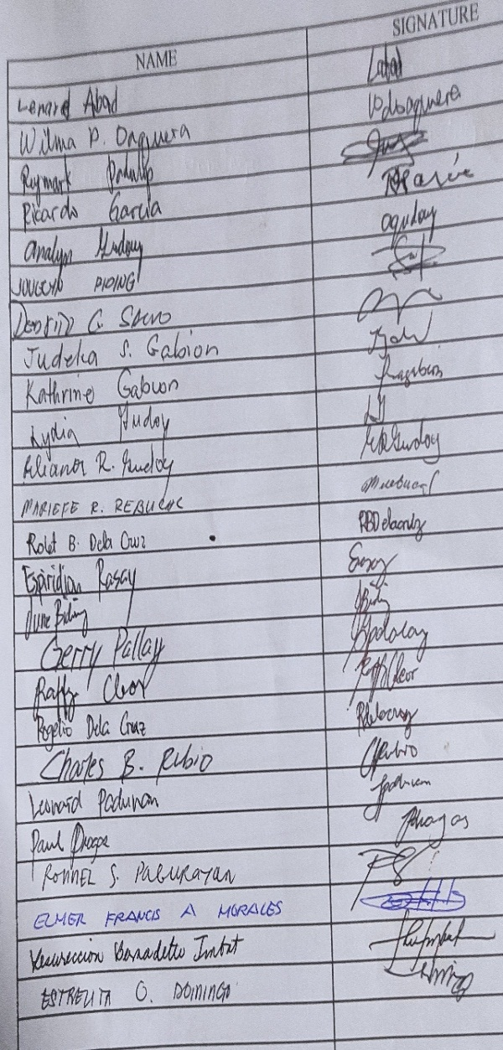

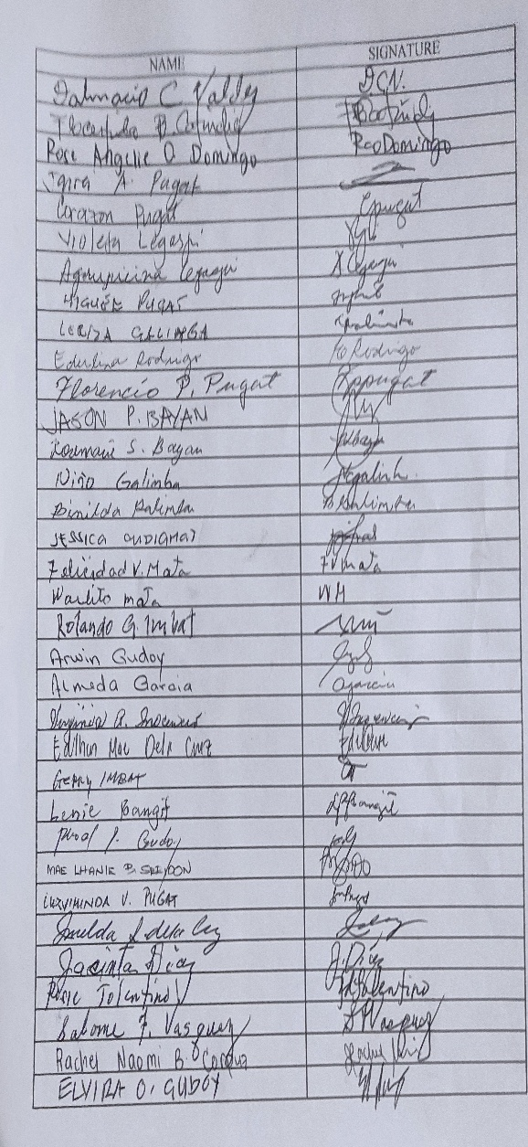

**Appendix D: Plates**

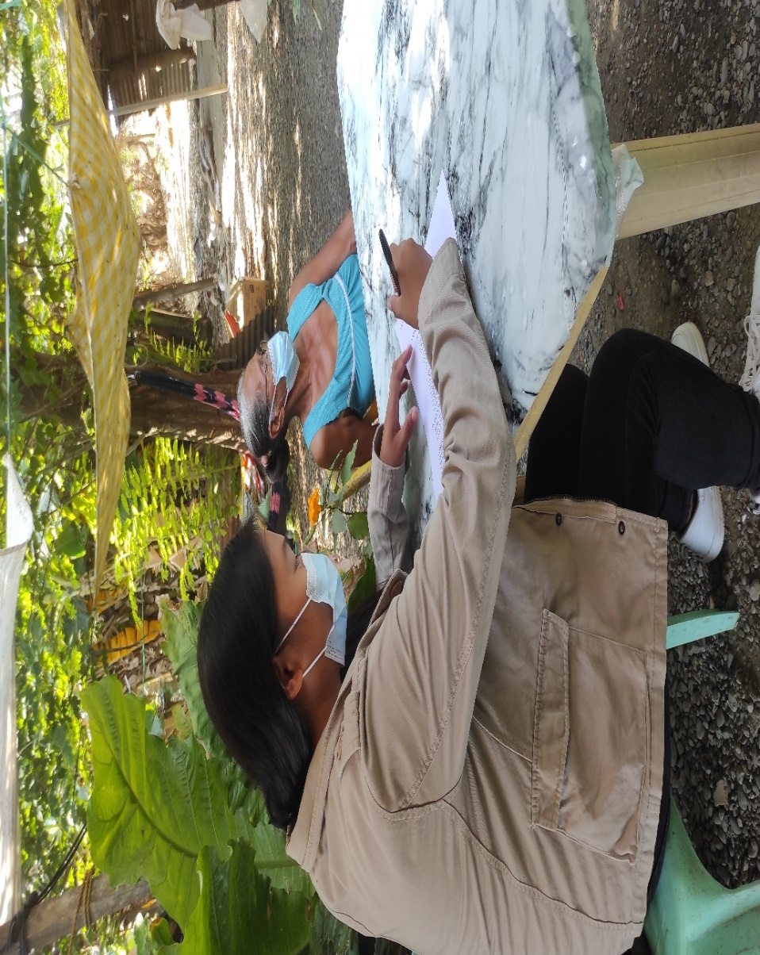

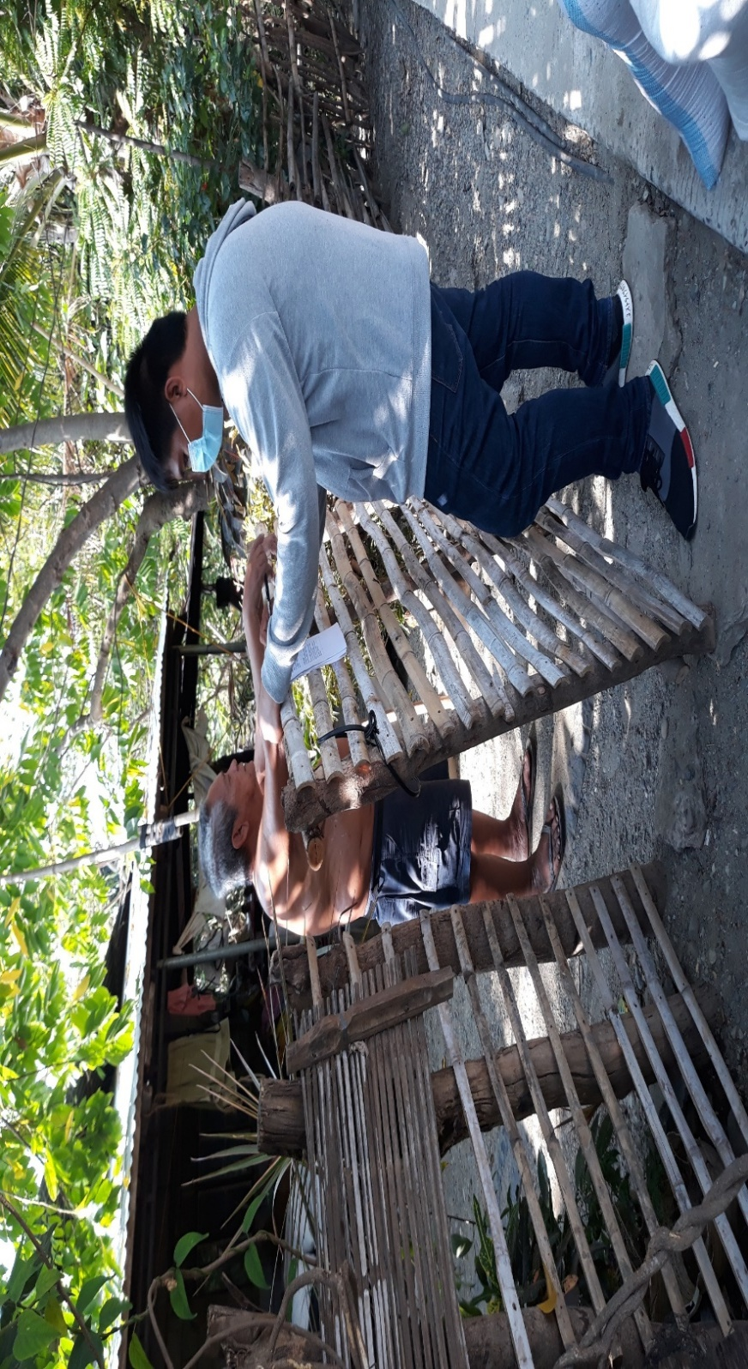

1. The researchers interviewing the respondents

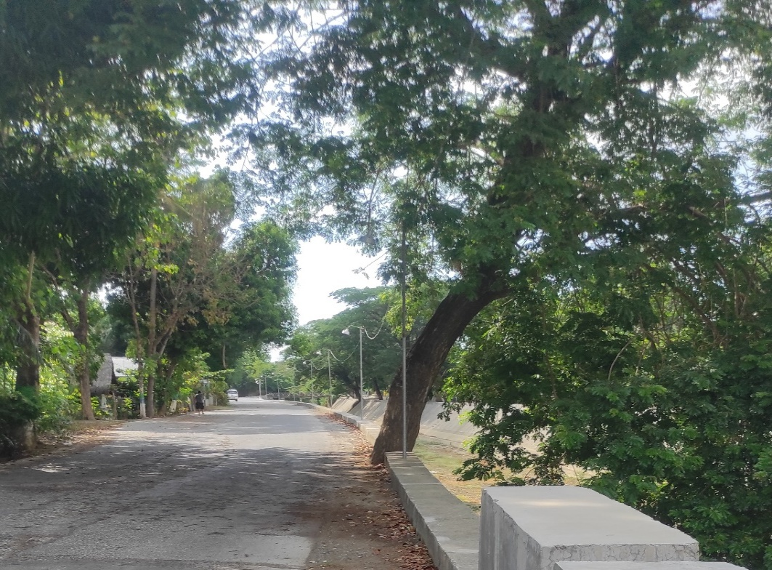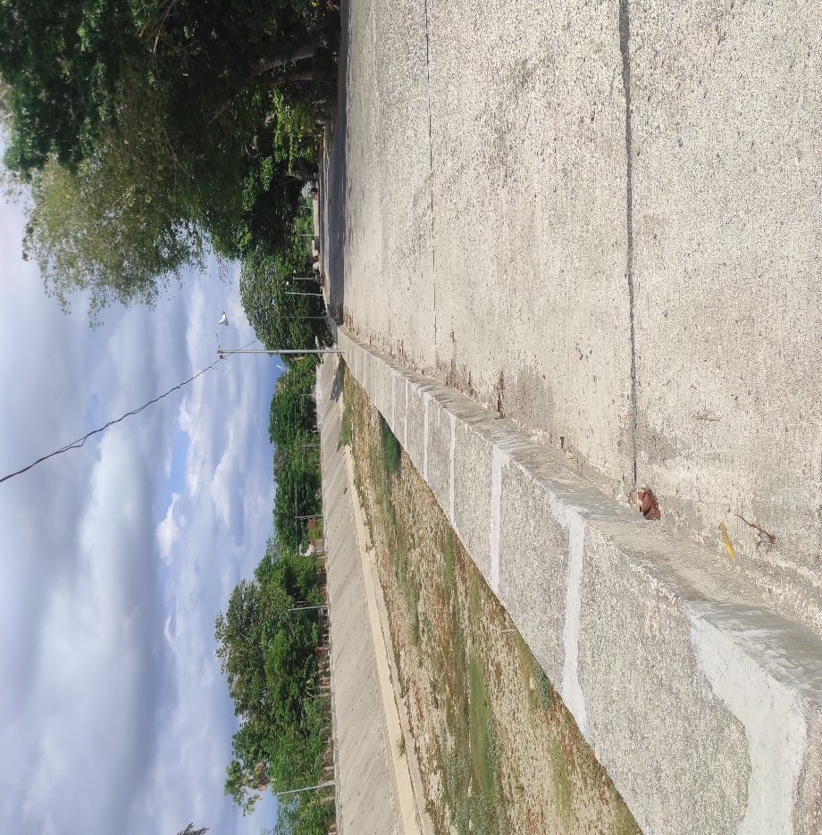2. The newly constructed road and dike

3. The remaining tree of the eradicated riparian area

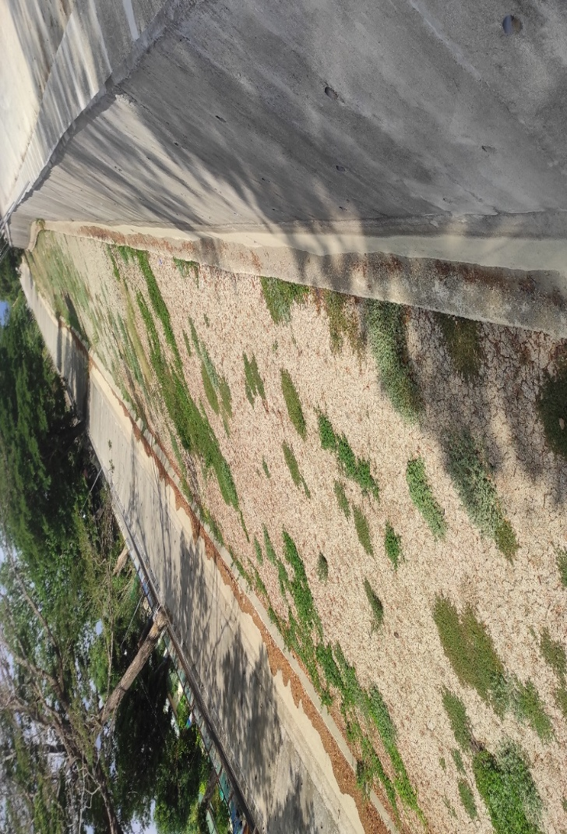 4. The exposed river bed along the eradicated riparian area